**Go to** [**https://marketplace.atlassian.com/**](https://marketplace.atlassian.com/)

**On top right side. Click on Avatar and in the drop down click ‘publish new app’**

**Fill the following fields:**

**1st PAGE—-**

**Vendor:** Register the vendor account and your organization and contact details

That just below the vendor select box

**Upload your app** : Forge App

**Choose a Forge App**: SIRP-JAN-2

**App Key**: App key is completely up to you (as long as it doesn’t contain invalid characters). As in the example, you could do something like: com.yourcompany.confluence.codex-for-team

**Name**: SIRP SOAR

**Compatible application**: Jira — Ticked both Jira Service Management, Compatible with Jira Software

**Build number:** 10020000(1.2.0)

**2nd PAGE—-**Get started:

**Payment mode**l: free

**About App:**

Logo:



**Name:** SIRP SOAR

Tagline: An App that closes incidents on SIRP manually and automatically

**Summary:**This App allows users to prompt SIRP to close an incident that has been escalated to JIRA as an issue

Based on the configuration, there are two options available to close an incident on SIRP:

- Users can either close the incident manually by clicking on a button displayed on the JIRA issue panel.

- Or the incident can be closed automatically as soon as the JIRA issue status changes to "Done"

**Release behavior**: Publish App immediately after approval

**More details**: SIRP is a risk-based Security Orchestration Automation and Response (SOAR) platform. SIRP makes it easy for security teams to quickly realize value through our free integrations and automation playbooks that let you take your security investigations from manual to automation at lightning speed.

SIRP provides a powerful yet simple solution that applies risk scoring and context to accelerate your investigation and incident response time, instantly increase your team’s efficiency, and gain invaluable metrics to manage and continually improve your security operations performance.

Unlike other SOAR solutions, our platform removes the complexities and makes your life easier with a fully supported, white glove experience. Our team empowers you to stop wasting time building integrations and spend more time stopping threats by providing unlimited integrations and playbook automations—at no extra cost. That’s our peace of mind commitment to you.

This SIRP JIRA App allows users to push the JIRA issue closure status to SIRP i.e. Close an Incident on SIRP",

**App store personal data:** No

**3rd PAGE—---Page design:**

Select Highlights

1. **Title:** Configure SIRP Application

**Summary**: Based on the configuration, there are two options available to close an incident on SIRP:

- Users can either close the incident manually by clicking on a button displayed on the JIRA issue panel screen.

- Or the incident can be closed automatically as soon as the JIRA issue status changes to "Done"

**Screenshot:**

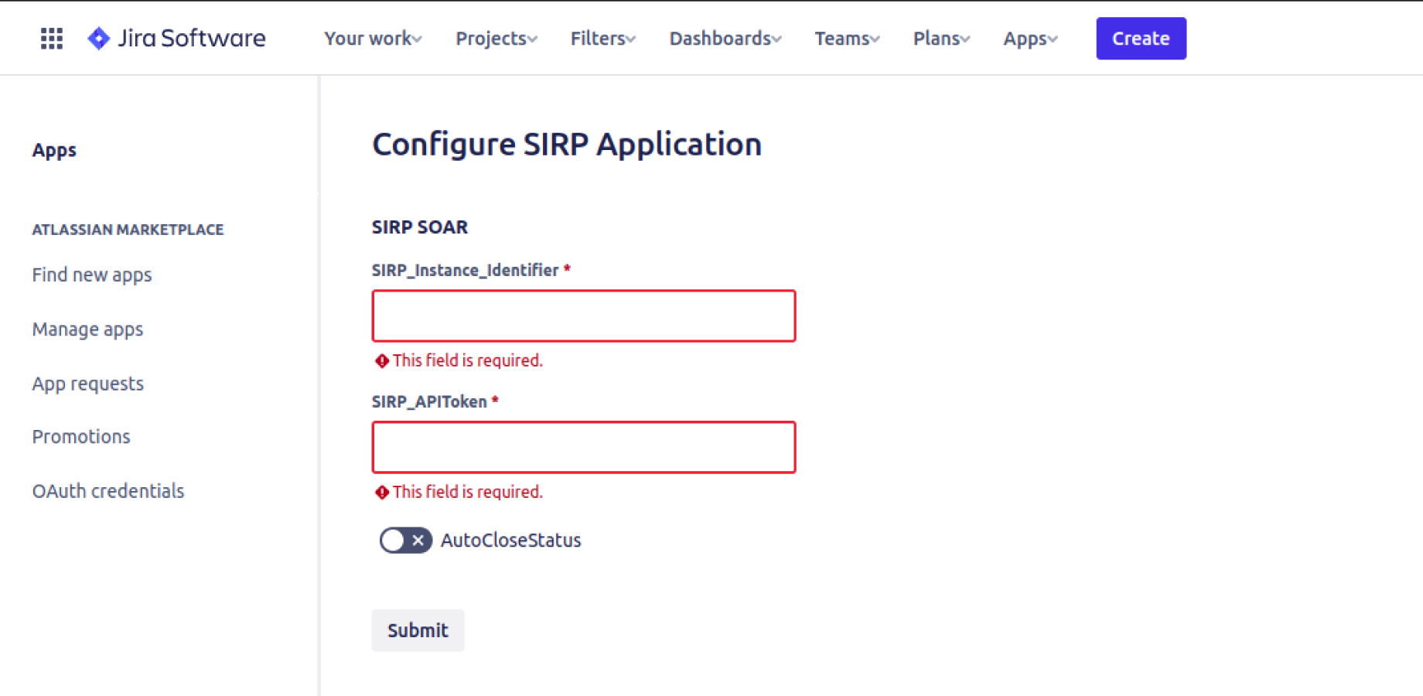

**Caption:** Configure SIRP Application

1. **Title**: Manual incident closure on SIRP

**Summary:** Users can close the incident manually by clicking on a button displayed on the JIRA issue panel. Additionally, the connection to the SIRP instance can be verified by clicking on the ‘check connectivity’ link.

**Screenshot:**

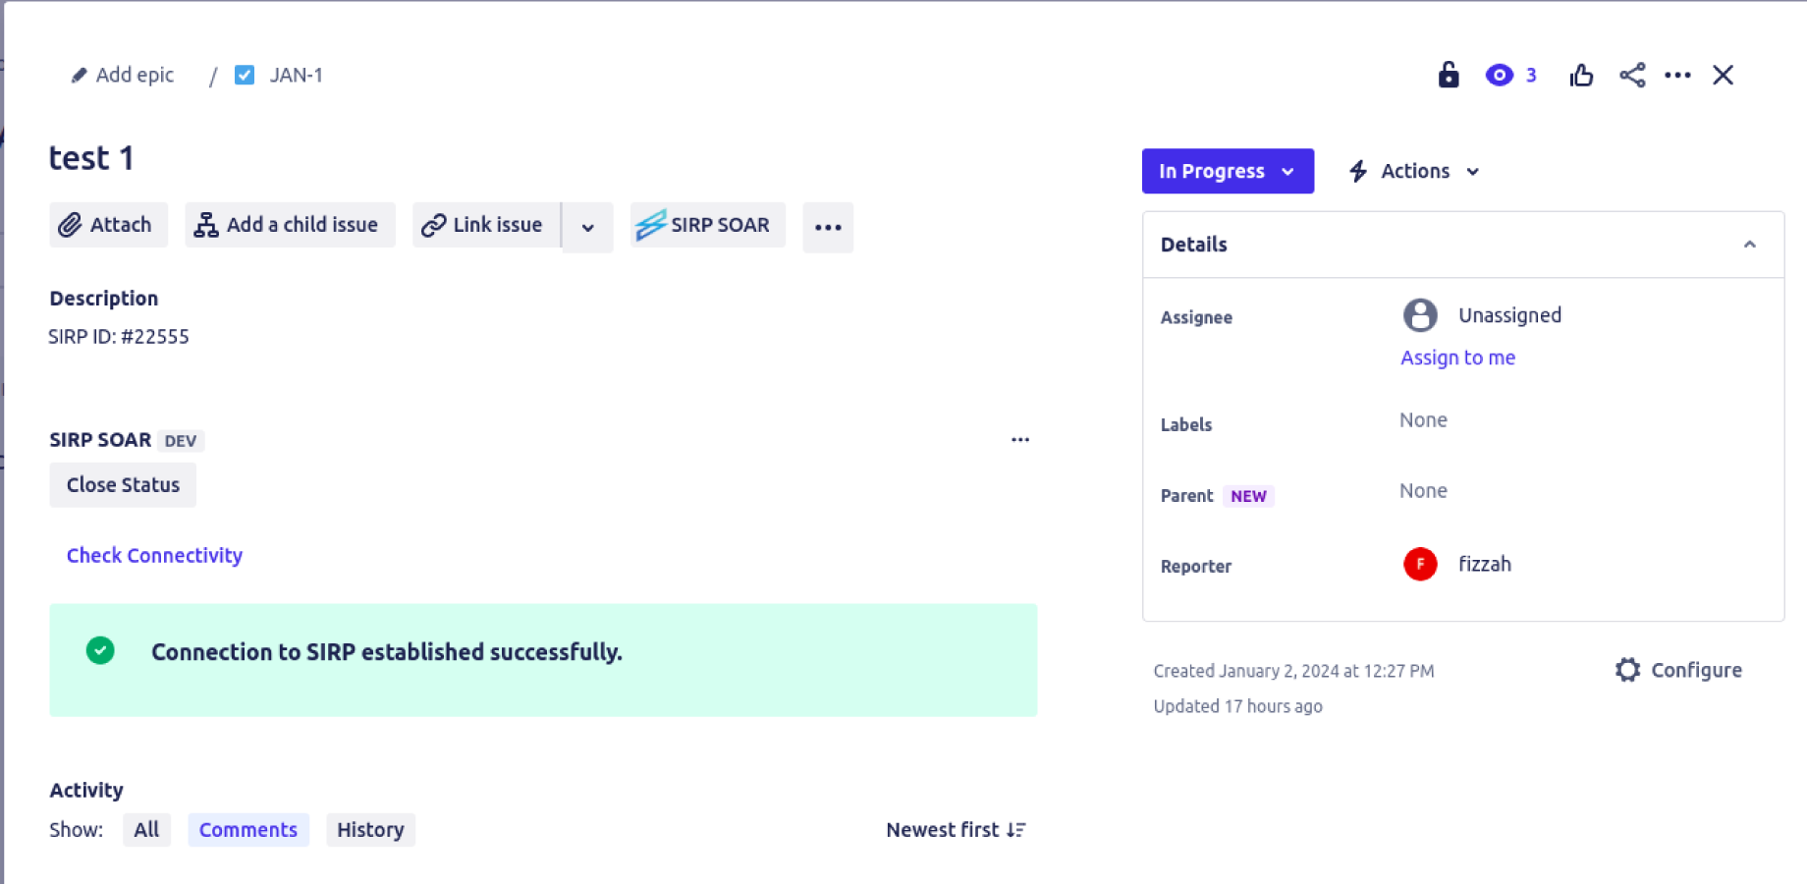

**Caption:** Manual Closure

1. **Title:** Automatic incident Closure on SIRP

**Summary:** The incident can be closed automatically as soon as the JIRA issue status is set to "Closed”. Additionally, the connection to the SIRP instance can be verified by clicking on the ‘check connectivity’ link.

**Screenshot**:

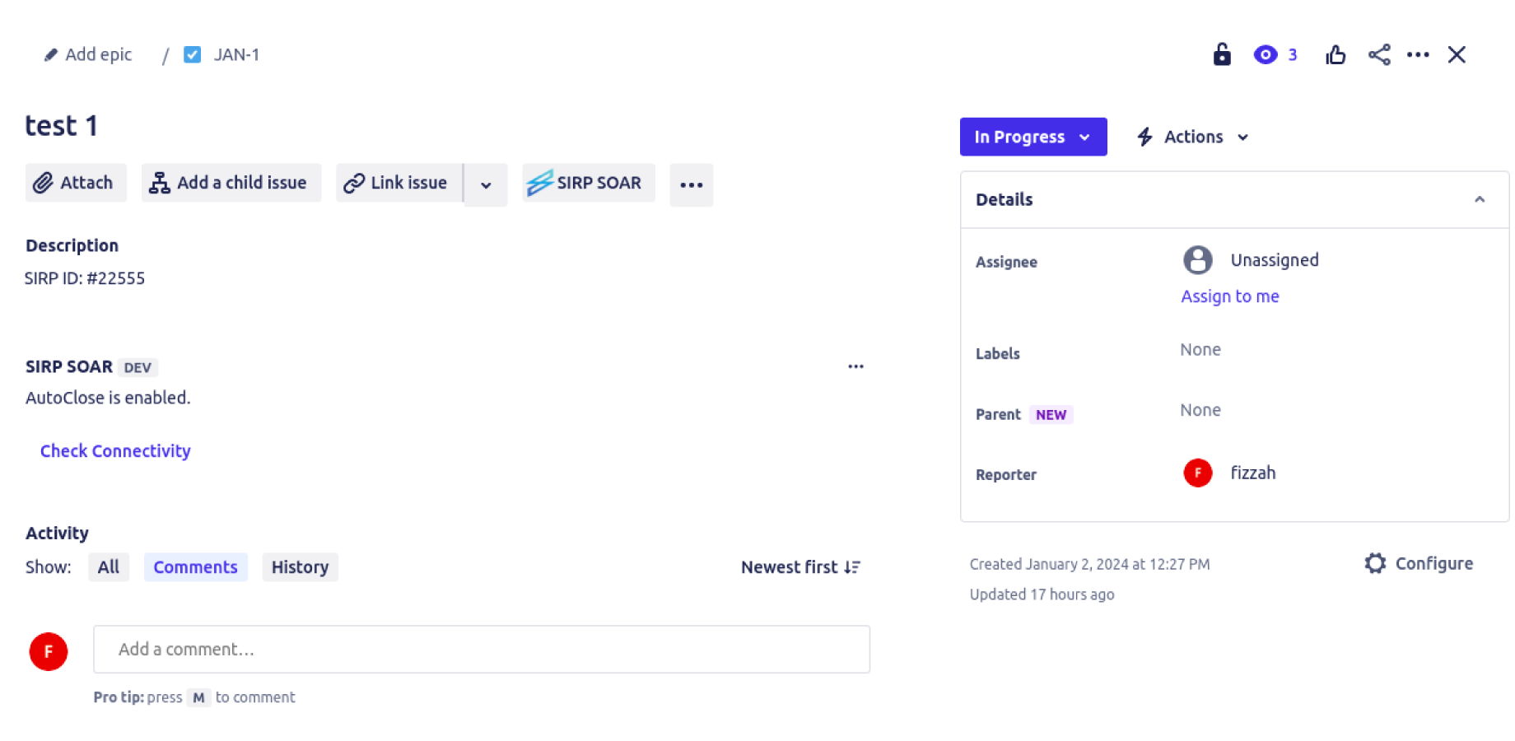

**Caption:** Automatic closure

**4rth PAGE—--Version page:**

Beta release check = if this is checked so jira add an icon that is listing that app is in beta phase

You may ask for feedback and or provide issue tracker for our customer to do testing and give feedback

**Release summary:** Click Install to to install the app. Then on the configuration page, add following details:

**Title:** SIRP SOAR

SIRP Instance Identifier: The URL of your SIRP instance

SIRP API Token: API Key generated by your respective user

Manual/Automated: Option to either close the incident automatically on Issue Status is set to “Closed” or manually by clicking a button.

Based on the configuration, there are two options available for closing the incident on SIRP:

Users can either close the incident manually by clicking on a button displayed on the Issue Panel.

Or the incident can be closed automatically as soon as the JIRA Issue status is set to Closed.

**Release note**: -Note: You can only close those incidents in SIRP which were escalated to JIRA as issues. Each Issue escalated from SIRP contains the respective ID of the incident in SIRP. If the ID is not present then there is no link between the JIRA Issue and SIRP incident.

**License:** Commercial

**App version officially supported**: yes

**Documentation:** https://docs.sirp.io/en/articles/8842086-sirp-soar-add-on-for-jira

Customer terms: https://

Data security and privacy statement: https://